1. When calling login API, need to set Request Headers properly,

client.DefaultRequestHeaders.Add("authority", "consulting.us-east-1.reveal11.cloud");

client.DefaultRequestHeaders.Add("path", "/rest/api/v2/login");

client.DefaultRequestHeaders.Add("scheme", "https");

client.DefaultRequestHeaders.Add("accept", "application/json");

client.DefaultRequestHeaders.Add("accept-encoding", "gzip, deflate, br");

client.DefaultRequestHeaders.Add("accept-language", "en-AU,en;q=0.9");

//client.DefaultRequestHeaders.Add("content-length", "60");

//client.DefaultRequestHeaders.Add("content-type", "application/json-patch+json");

client.DefaultRequestHeaders.Add("origin", "https://consulting.us-east-1.reveal11.cloud");

client.DefaultRequestHeaders.Add("referer", "https://consulting.us-east-1.reveal11.cloud/rest/api-docs/index.html?urls.primaryName=v2");

client.DefaultRequestHeaders.Add("sec-ch-ua", "\"Chromium\";v=\"110\", \"Not A(Brand\";v=\"24\", \"Google Chrome\";v=\"110\"");

client.DefaultRequestHeaders.Add("sec-ch-ua-mobile", "?0");

client.DefaultRequestHeaders.Add("sec-ch-ua-platform", "\"Windows\"");

client.DefaultRequestHeaders.Add("sec-fetch-dest", "empty");

client.DefaultRequestHeaders.Add("sec-fetch-mode", "cors");

client.DefaultRequestHeaders.Add("sec-fetch-site", "same-origin");

client.DefaultRequestHeaders.Add("user-agent", "Mozilla/5.0 (Windows NT 10.0; Win64; x64) AppleWebKit/537.36 (KHTML, like Gecko) Chrome/110.0.0.0 Safari/537.36");

1. To generate Swagger SDK, download codegen Jar file from the link below:

<https://repo1.maven.org/maven2/io/swagger/swagger-codegen-cli/2.4.9/>

Run this command to create package:

*java -jar swagger-codegen-cli-2.3.1.jar generate -l csharp -i https://consulting.us-east-1.reveal11.cloud/rest/swagger/docs/v2 --api-package Api.Resources --model-package Models.Resources -DmodelTests=false -DapiTests=false -DpackageName='RevealAPI.Sdk'*

1. The SDK created by codegen had compiling issues for enum, remove circular references;

Complete = Complete, => Complete,

Also had to get rid of some incorrect lines (3?) to allow compiling;

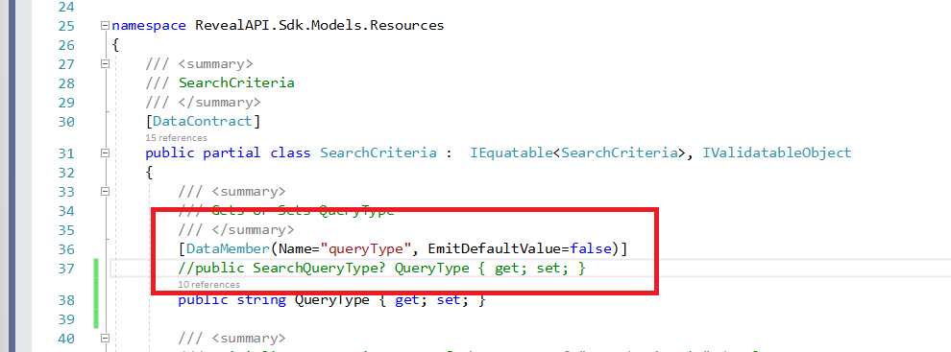

1. Retrieve text